## Wood Game: User Manual

Wood Game is an Android game where the player takes control of a small hero lost in the forest. He needs to find his way through different levels, avoiding hazards along the way.

The game is easy to get into but can be challenging, since in this game, the clock is against you. You need to finish a level as quickly as possible, the lower time the better.

The game has a number of interesting features

* Animated graphics
* Interactive terrain: movable blocks, dangerous water, teleportation blocks
* Items: Locks & keys
* Music and sound
* A highscore list: Make your name known as you try to beat the score of others.

On the following pages you will find a guide on how to play Wood Game.

## Starting the game

After the splash screen you will be welcomed with a menu screen with two buttons. The green one starts the game and the red one closes the application.

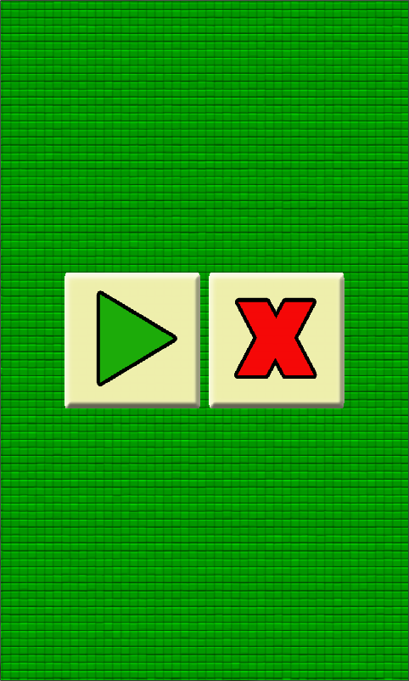

Afterwards you are asked to enter a username so you can put your name on the highscore list. The name needs to be atleast 3 characters long.

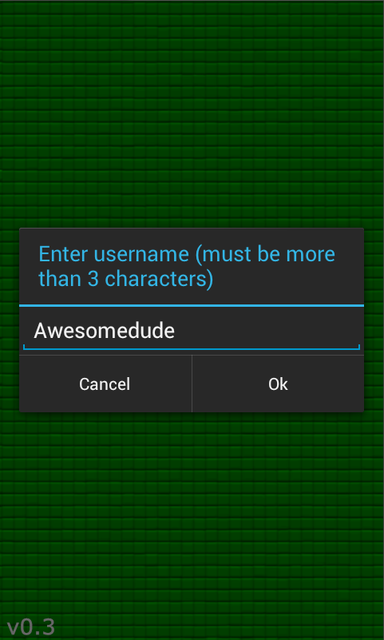

## Playing the game

In the game you control the hero by touching the dpad on the lower right of the screen. The character can move in four different directions. Holding the dpad in one direction lets the hero move in that direction repeatedly. On the lower left of the screen you will see the time currently spent on the level. There is also a text telling you how many keys the hero is currently carrying.

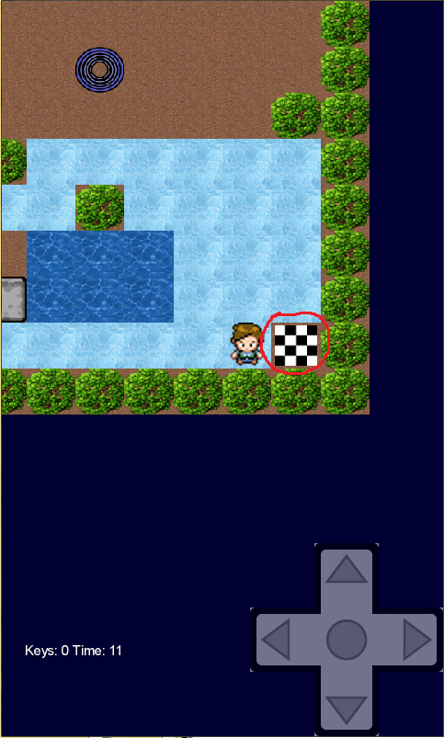

To complete a level, the hero must reach the ending tile. (shown on the picture above, marked with a red circle.)

## Interacting with the level

During a level you might stumble upon gray blocks. These can actually be moved by the hero by moving right beside it, thus pushing it forward. A block can also be used to create safe ground for the hero to walk on by pushing it into water.

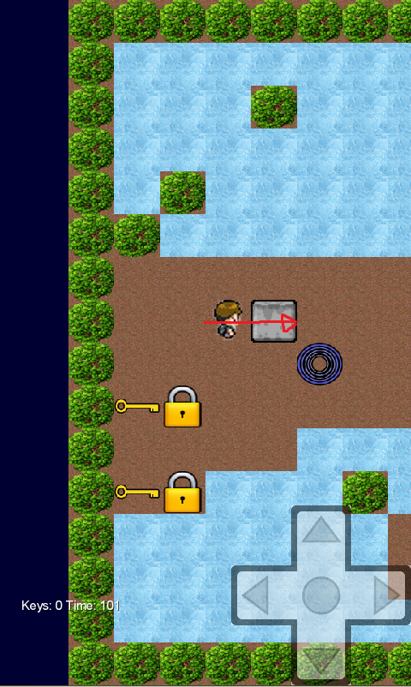

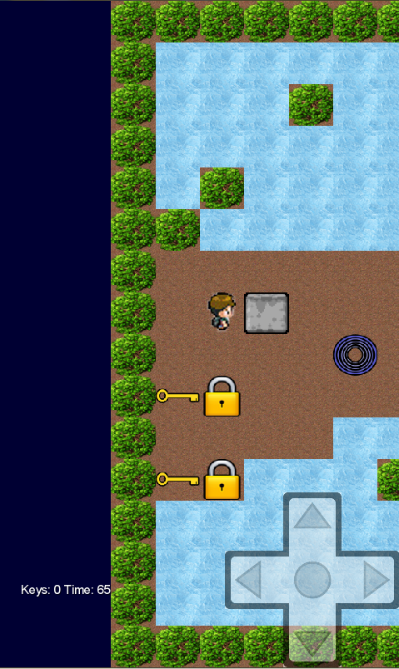

The hero might also stumble upon locks that cannot be passed unless the hero is carrying a key. To pick up a key, simply walk into it and the number of keys on the lower left of the screen will be updated with your new number of keys. To unlock a lock, walk into it when carrying a key and it will remove the lock so the hero can get through. (See below)

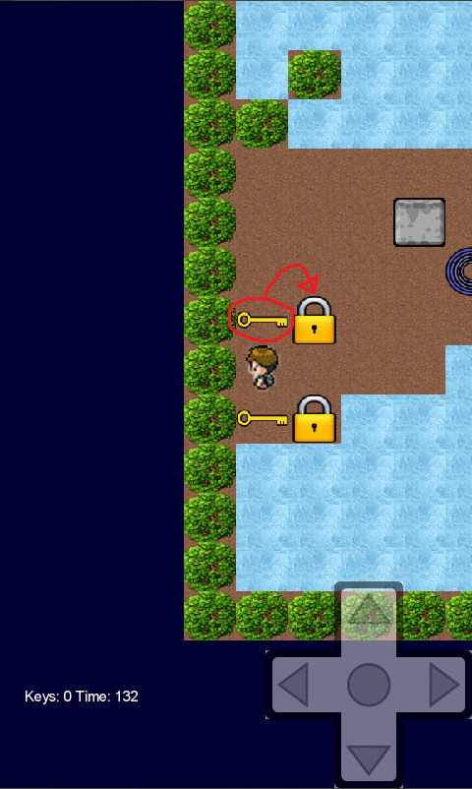

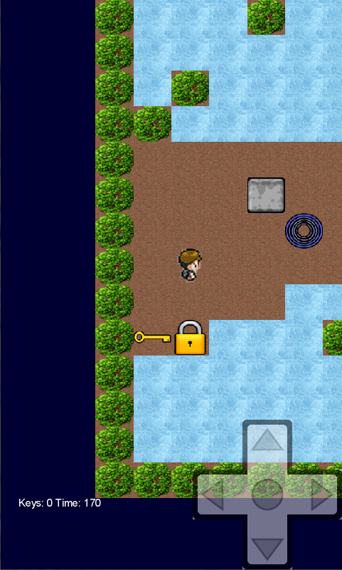

Teleporter pads also exist on some levels. Going into a teleporter pad instantly moves the hero from one teleporter to another with the same colour. (See below for how a teleporter pad looks like, circled in red.)

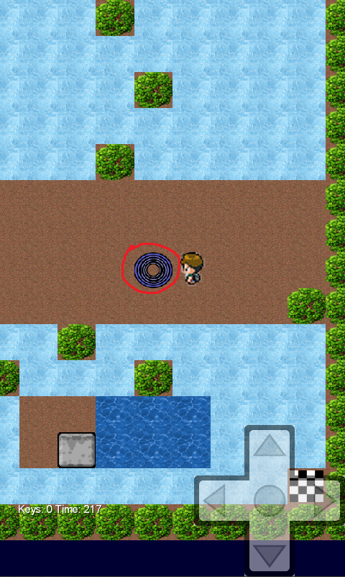

There are hazards that the hero must avoid aswell. Going on ice can be dangerous since you cant stop moving until you reach a wall or a dirt tile. Fire and water are hazards must be avoided since they instantly kill the hero. This can be especially dangerous in combination with ice where you cant completely control the hero’s movement. (Hazards shown at arrows below)

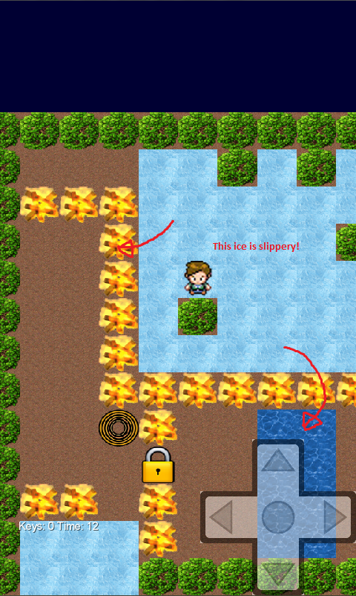

However, the hero can move a block into water to create a new walkable tile for him to safely traverse.

